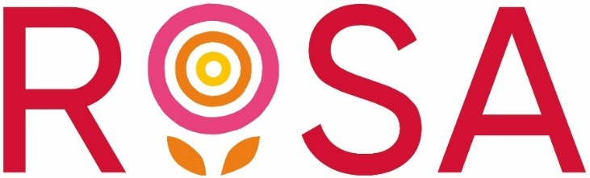

Stand with Us Fund – Frequently Asked Questions (FAQs)

Who can I contact if I have an enquiry?
Please contact grants@rosauk.org, making sure you include your organisation name in the email. We aim to respond to your email within 5 working days.

I need accessibility support with the application form. How can I get support?
Please get in touch to discuss how we can help. You can contact us by email: grants@rosauk.org

- I’m having technical difficulties with the online application form, can you help?
You can find details of how to apply in our application guidance. The application process has two steps:
- Registration form and eligibility check
- Application form
Please note that you need to complete the registration form before accessing the application form. The registration form will ask for your name, contact details, and the name of your organisation. You will also be asked to answer a series of eligibility questions. Please note that we can only consider applications from organisations which meet all our eligibility criteria.
Once you submit the registration form, and provided your organisation is eligible for funding, you will receive an email with a link to the application form.
If you would like to plan your answers before going online to fill in the form, the application form questions are listed at the end of the application guidance.
If you need further technical assistance, please contact us at grants@rosauk.org

Do organisations have to be registered as a charity to apply?
No, but their activities must be charitable, legal and for the benefit of women and/or girls. They must also have all of the supporting documents listed in the application guidance.

Do you fund non-constituted groups?
No. Whilst organisations do not need to be a registered charity to apply, we do require organisations to have a governing body and to be constituted.

If we don’t have independently examined or audited accounts yet, will you accept management accounts?
No. You must be able to provide one year of annual accounts.

Can you accept an application from a partnership of two organisations?
We will not accept applications made in partnership with another organisation, or organisations applying to the fund on behalf of another organisation.

How will funding decisions be made?
Once the fund is closed, we will work with assessors to carry out eligibility checks on all applications. This includes reviewing the application information and the supporting documents. We will also review the organisation’s online details, such as website, social media and any details listed by the organisation’s relevant governing body. We do not use Artificial Intelligence to assess applications.
This will be followed by a shortlisting stage. Applications will be shortlisted based on:
- Passing the eligibility checks
- How well the proposal fits with the aim and priorities of the fund
- A good geographic spread of applications across the four UK nations
- A number of organisations that have not received a grant from Stand With Us Fund round 2 (awarded in 2024/25)
- Rosa will prioritise the following types of organisation:
  - Organisations operating in the top 10% most disadvantaged areas in the UK – based on the Indices of Multiple Deprivation (IMD);
  - Organisations based in Scotland, Wales or Northern Ireland;
  - Organisations led by and for either: Black and minoritised women and girls, disabled women and girls; or LGBTQ+ women and girls
Shortlisted applications will undergo a full assessment which may include a call with the applicant. The final funding decision will be made by a panel comprised of Rosa Trustees and experts from the VAWG sector.

What if my application is unsuccessful?
We understand that you will have spent a lot of time completing your application and that it will be disappointing to not be successful. Unfortunately, due to the high demand for funding, Rosa receives far more high-quality applications than we can fund.
If your application is unsuccessful, we will write to you outlining the reasons why. We provide feedback on common errors and application weaknesses.
Decisions cannot be appealed, but if you have a complaint about how your application has been processed, please contact Rosa’s Chief Executive at confidential@rosauk.org

Will further rounds be available after this?
Please sign up to our newsletter on the Rosa website for updates on any Rosa funding that is available in future.

